FOR IMMEDIATE RELEASE
Contact: Tim Demy
401-862-1099,
tim@stonetowerpress.com

Pseudo-Cyril of Alexandria
Commentary on the Apocalypse
Introduction, Translation, and Transcription of a Lecture on Revelation 7—12 from Sixth-Century Egypt

Francis X. Gumerlock with Francesca Lecchi and Tito Orlandi
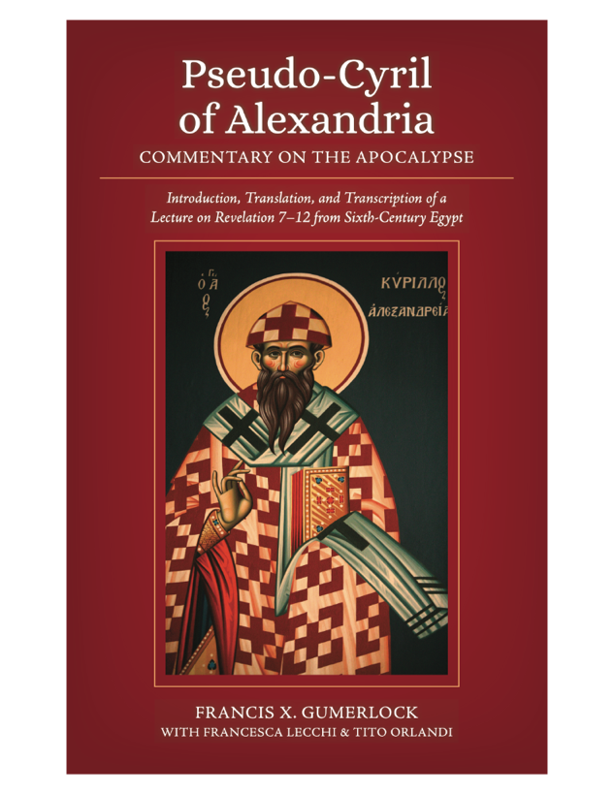
Published in English for the first time, these pages provide an introduction, translation, and transcription of a late-sixth century lecture on Revelation 7–12. Given in an Egyptian monastery by an unknown teacher and written in the Sahidic Coptic dialect, the lecture circulated in the name of Cyril of Alexandria (d. 444). The manuscript copy was discovered in 1910.
Herein titled Encomium, the commentary manuscript likely derived from the scriptorium in the ancient Egyptian city of Touton.

The Encomium was part of a lecture series on the Apocalypse, most likely by a visiting monk, teacher, or bishop. The text is probably a transcription
of the lecture by one of the hearers and the one lecturing appears to use a translation of the Book of Revelation into Sahidic Coptic. The extensive introduction provides readers with important historical,
exegetical, and theological background for understanding this remarkable writing on the Book of Revelation and its reception in sixth-century Egypt.
- ISBN: 978-1-7368651-6-3
- Pages: 154
- Paperback
- Price: $24.95
- Genre: Biblical Studies, Theology, Christianity
- Publication: Fall 2021

Francis X. “Frank” Gumerlock, PhD, teaches Latin in Colorado. He is the author of nine books, many of which are translations of early and medieval Latin texts on the Book of Revelation and the theology of grace, including Carolingian Commentaries on the Apocalypse by Theodulf and Smaragdus (2019) and Tyconius. Exposition of the Apocalypse (2017).

